- Diwali Bazaar Sales Analysis
- by-Mani Kaur

1. Introduction
The objective of this project is to perform Exploratory Data Analysis (EDA) on the Diwali Bazaar Store dataset to understand customer purchasing behavior during festive sales.
The analysis focuses on identifying:
- Customer demographics
- Purchasing trends
- State-wise sales performance
- Product category preferences
- Gender and occupation-based buying behavior
The project utilizes Python libraries, including Pandas, NumPy, Matplotlib, and Seaborn, for data cleaning, analysis, and visualization.

➜ Importing Required Libraries
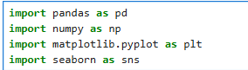
These libraries were used for:
- Data manipulation
- Numerical operations
- Data visualization
- Statistical analysis

➜ Loading the Dataset

➜ Understanding the Dataset

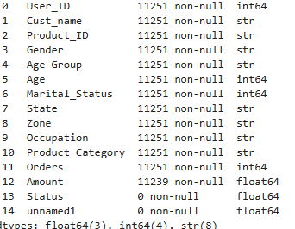

Dataset Information
- Total Rows: 11,251
- Total Columns: 15
- Numerical Columns:
  - Age
  - Orders
  - Amount
- Categorical Columns:
  - Gender
  - State
  - Occupation
  - Product Category
The dataset also contained unnecessary columns:
- Status
- unnamed1
These columns contained missing values and were removed.

➜ About the Dataset
✦ The dataset contains 11,251 customer records with multiple categorical and numerical features.
✦ The dataset includes customer demographic details and purchasing information collected during Diwali sales.
✦ It helps analyze customer buying behavior and identify sales trends.
✦ The dataset contains both:
- Numerical data
- Categorical data
✦ The analysis provides business insights for improving customer targeting and sales strategies.

➜ Data Preprocessing

Removing Unnecessary Columns
The columns Status and unnamed1 were removed because they contained only null values and were not useful for analysis.

➜ Checking Missing Values

Observation
- Only the Amount column contained missing values.
- Total missing values found: 12

➜ Handling Missing Values
After removing rows with missing values:
- Total rows reduced from 11,251 to 11,239
This improved data consistency and reliability.

➜ Changing Data Types
The Amount column was converted from float to integer format for better analysis and visualization.

➜ Descriptive Statistical Analysis

Key Insights
✦ Average customer age was approximately 35 years
✦ Maximum customer age recorded was 92 years
✦ Average order quantity was around 2 to 3 orders
✦ Average purchase amount was approximately 9453
✦ Maximum purchase amount recorded was 23952
✦ Most customers placed between 2 and 3 orders
This statistical summary helped understand customer spending patterns and purchasing behavior.

➜ Handling Inconsistent Data
The dataset was checked for:
- Duplicate records
- Incorrect values
- Extra spaces
- Inconsistent category names

Cleaning Performed
✔ Removed unnecessary columns
✔ Verified Gender values (M and F)
✔ Checked invalid numerical values
✔ Standardized categorical columns
✔ Removed formatting inconsistencies
✔ Verified Age Group consistency with Age
After cleaning, the dataset became reliable for analysis.

Exploratory Data Analysis (EDA)

1. Gender Analysis

Count of Customers by Gender
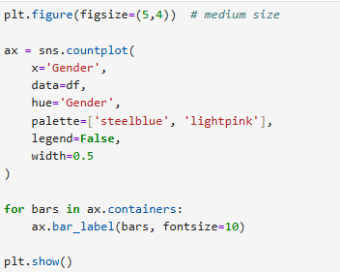

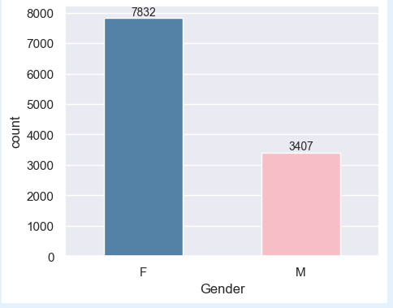

This visualization shows the number of male and female customers in the dataset.

Gender-wise Sales Analysis
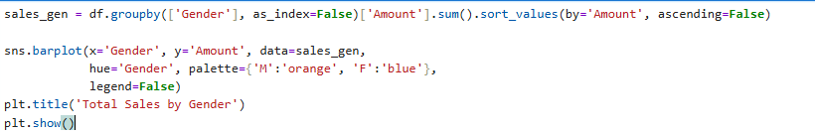
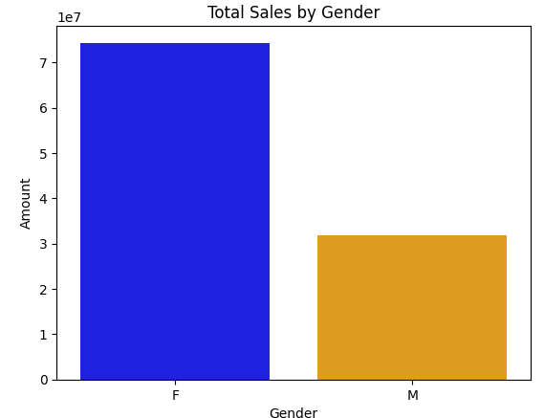

Observation
Female customers contributed more to overall sales compared to male customers.

2. Age Group Analysis

Customer Count by Age Group
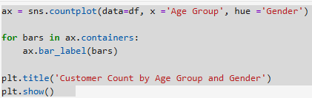

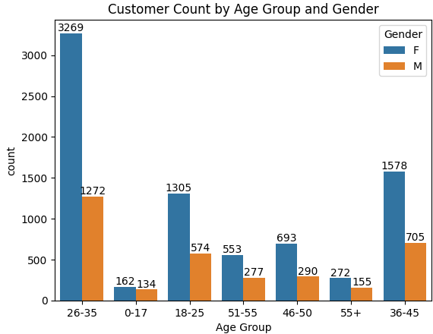
Customers belonging to the 26–35 age group made the highest purchases during Diwali sales.
Female customers in this age group contributed significantly to total revenue.

3. State-wise Sales Analysis

Top 10 States by Orders
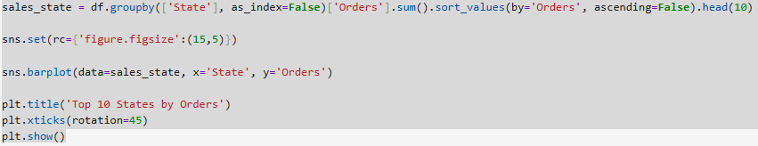
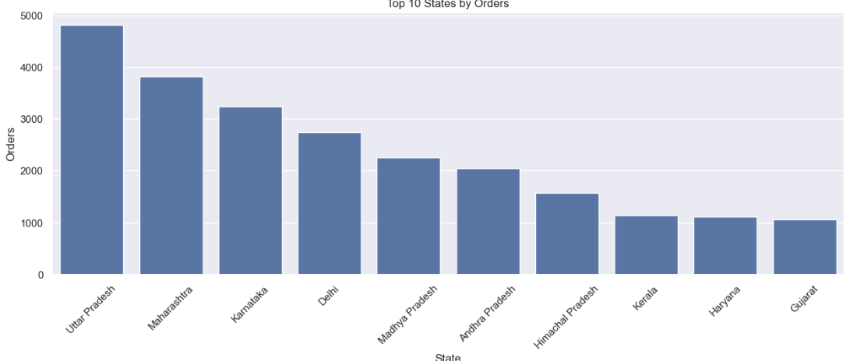
The highest number of orders came from:
• Uttar Pradesh

• Maharashtra

Top 10 States by Sales Amount
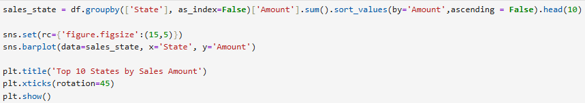

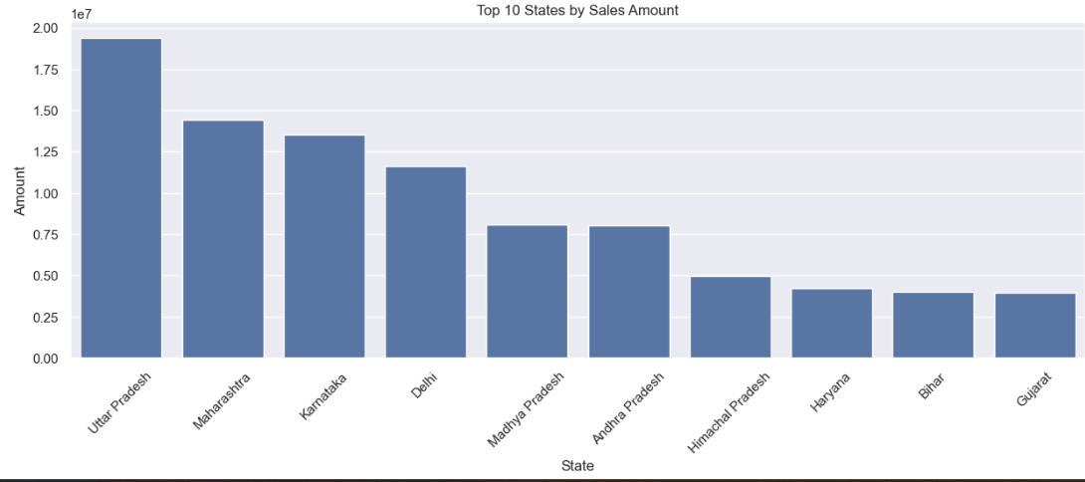

Observation
These states generated the highest revenue:
- Uttar Pradesh
- Maharashtra
- Karnataka
This indicates strong customer engagement in these regions.

4. Marital Status Analysis
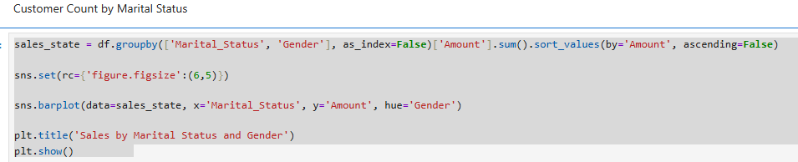

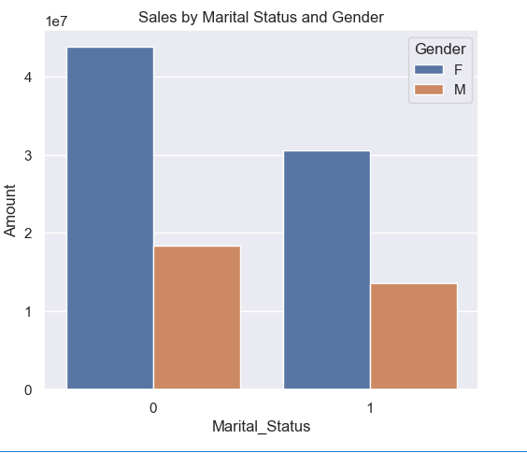

Observation
Married women contributed significantly more to sales compared to other customer groups. This customer segment showed high purchasing behavior during festive shopping.

5.Occupation Analysis

Customer Count by Occupation

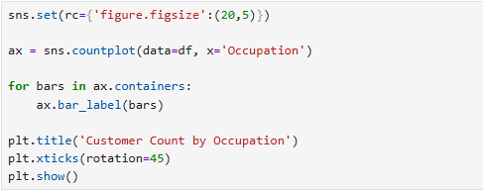

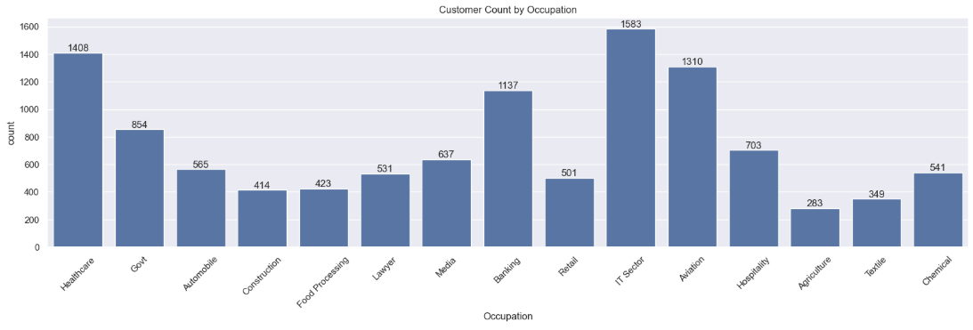

Customers working in:
IT
Healthcare
Aviation
were among the most active buyers.

Occupation vs Sales
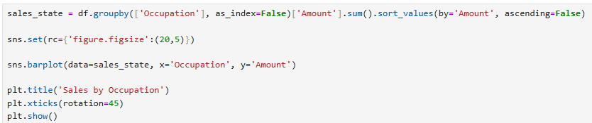

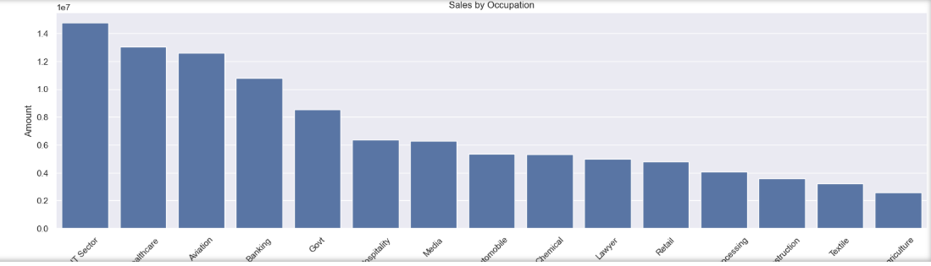

Observation
The highest sales contributions came from customers working in:
- IT Sector
- Healthcare
- Aviation

6. Product Category Analysis

Product Category Count

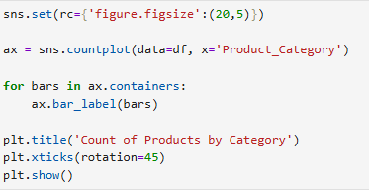
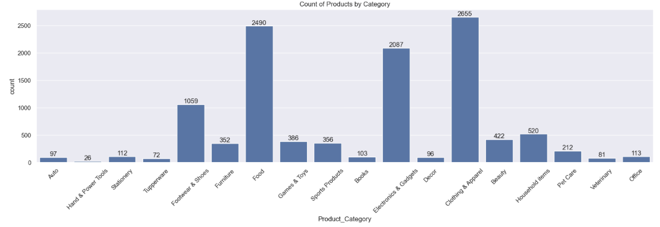

Observation
The most frequently purchased categories were:
- Food
- Clothing
- Electronics

Product Category vs Sales

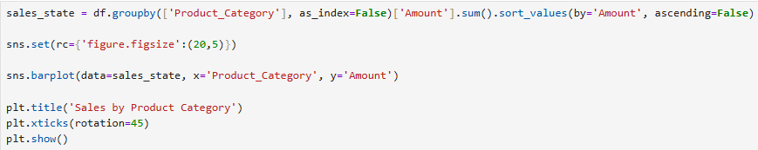

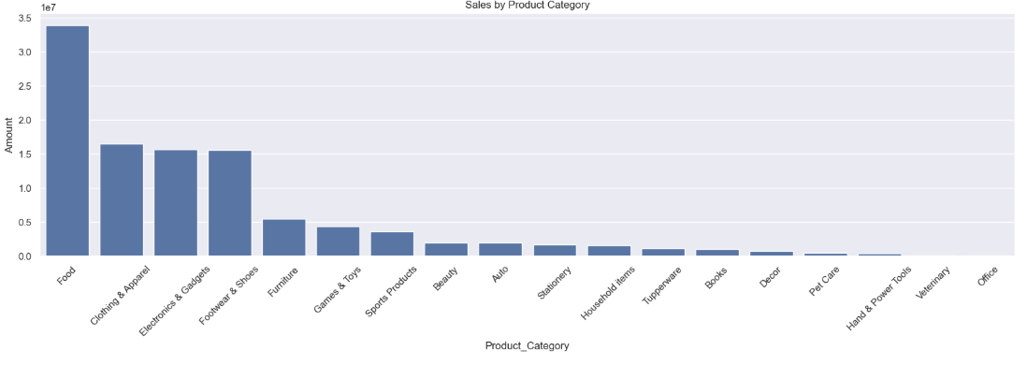

Observation
Food, Clothing, and Electronics generated the highest sales revenue during Diwali.

➜ Final Conclusion

Key Findings from the Analysis
✔ Female customers contributed more to total sales.
✔ Customers aged between 26–35 years were the most active buyers.
✔ Uttar Pradesh, Maharashtra, and Karnataka generated the highest sales.
✔ Married women showed higher purchasing behavior.
✔ Customers from IT, Healthcare, and Aviation sectors contributed significantly to revenue.
✔ Food, Clothing, and Electronics were the top-selling product categories.

➜ Business Recommendations
✔ Focus marketing campaigns on female customers aged 26–35.
✔ Increase promotional offers in top-performing states.
✔ Target married women with festive discounts and personalized offers.
✔ Expand inventory for high-demand categories such as Food and Electronics.
✔ Create occupation-based marketing strategies for IT and Healthcare professionals.
➜ Tools & Technologies Used
Tool/Library | Purpose
Python | Data Analysis
Pandas | Data Cleaning
NumPy | Numerical Operations
Matplotlib | Data Visualization
Seaborn | Statistical Charts
MS Excel | Dataset Source
Jupyter Notebook | Coding Environment

